Air Quality Eggs Website

- How to use the website (Mac computers):

1. Make sure you have all the files on your computer (Javascript files (.js) and HTML files (.html)) and on the same folder;
2. Open the Terminal;
3. Use the command “cd” to get to the folder the files are living;

Example:

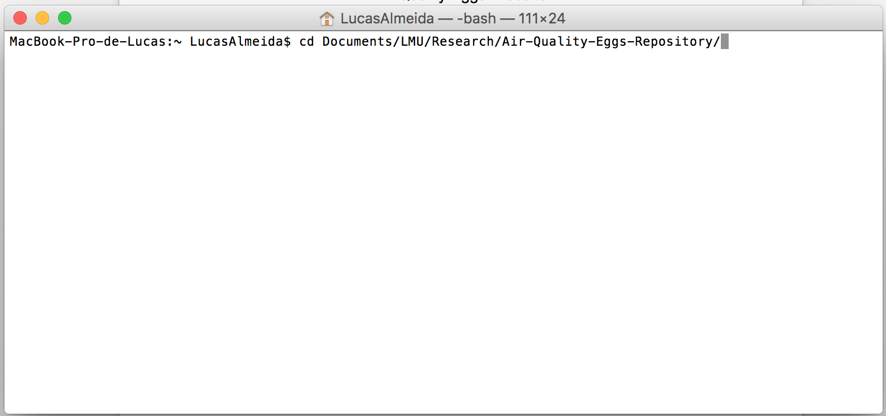

Press “Enter”:

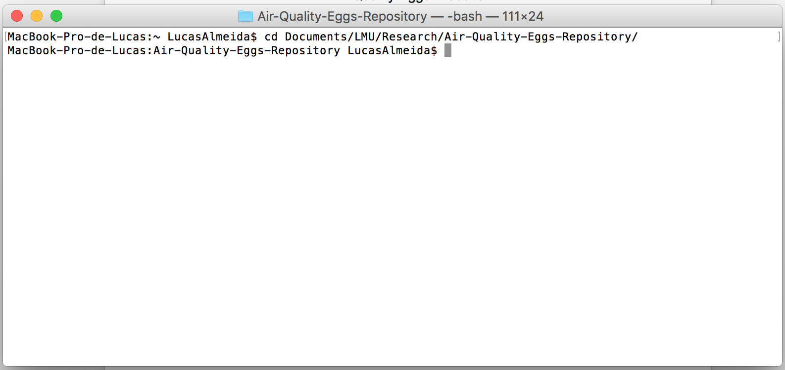

1. Once inside of the folder, use the command “python –m SimpleHTTPServer” to launch a simple server where the webpage will run;

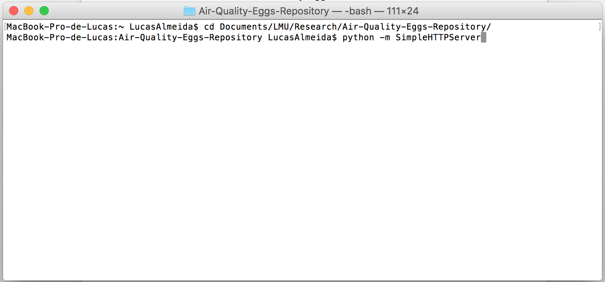

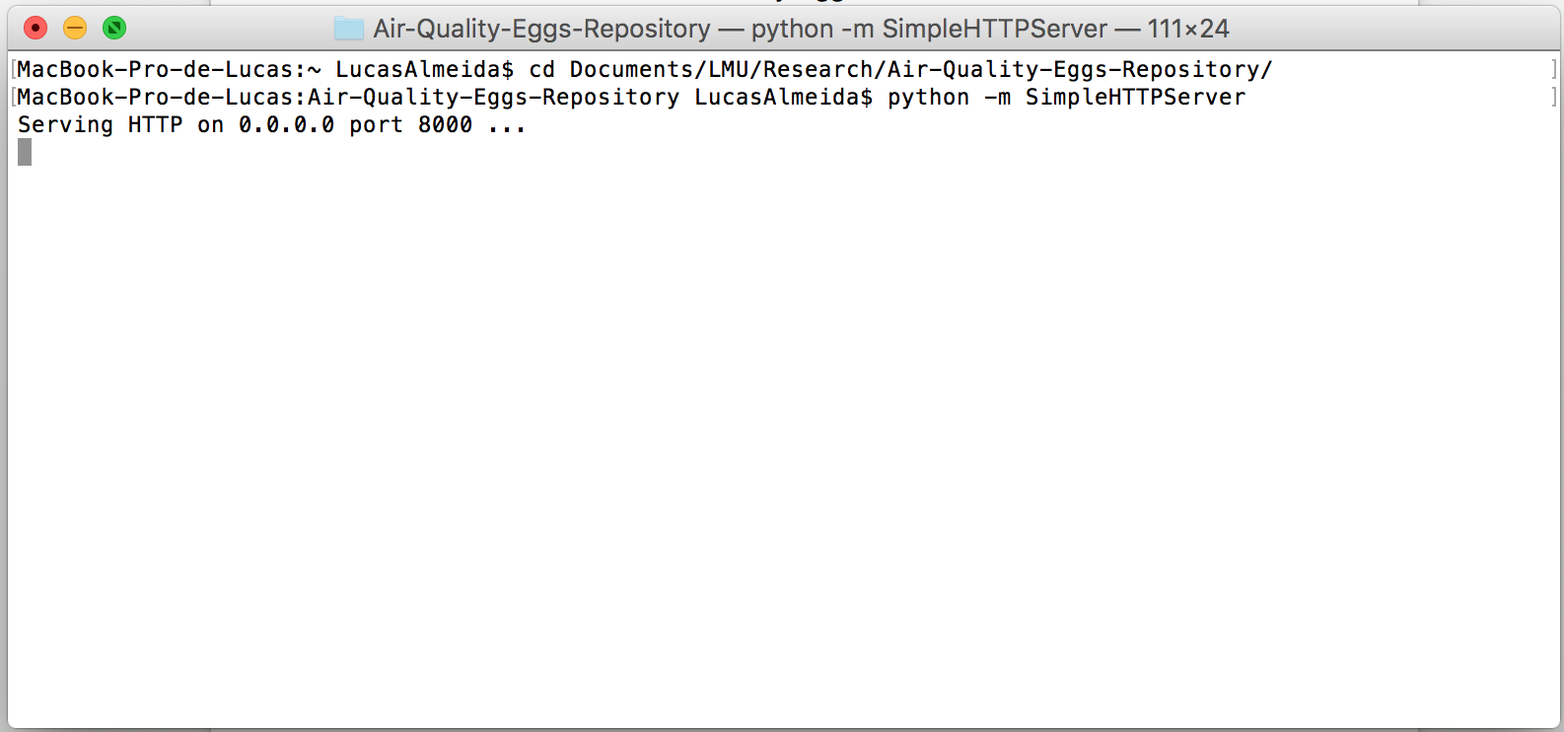

After this a simple HTTP server should be running on the folder selected.

1. Open an internet browser and type “localhost:8000” (the number 8000 comes from the port the server is using – see previous image);



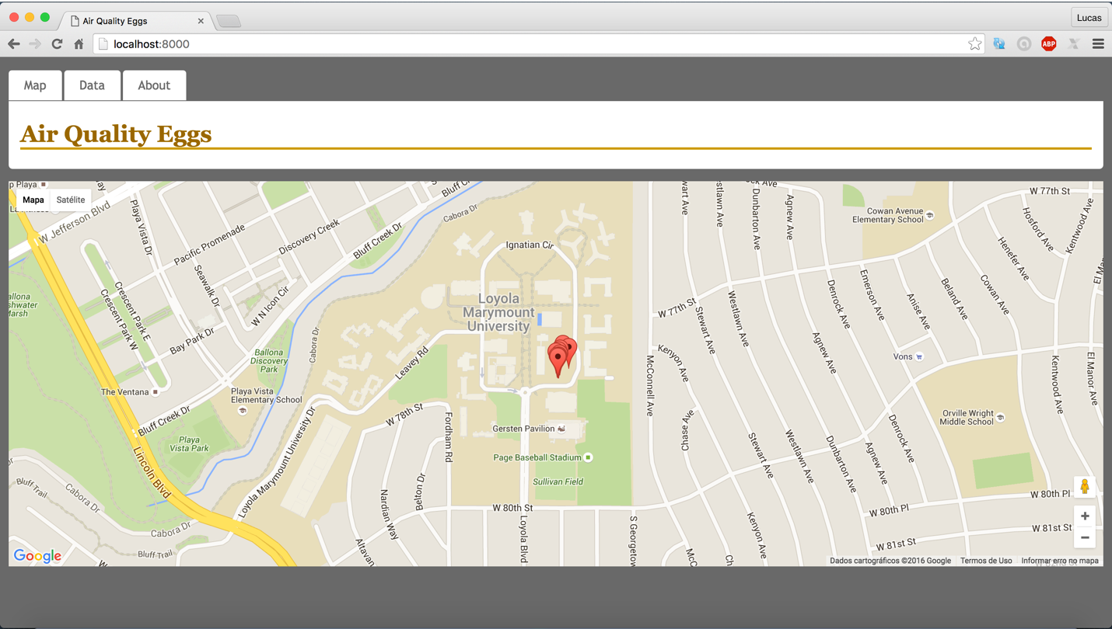

The website should appear and be ready to be used.

- Where do I find the files?

1. Go to the website <http://www.github.com>
2. On the search bar type: Air-Quality-Eggs-Repository

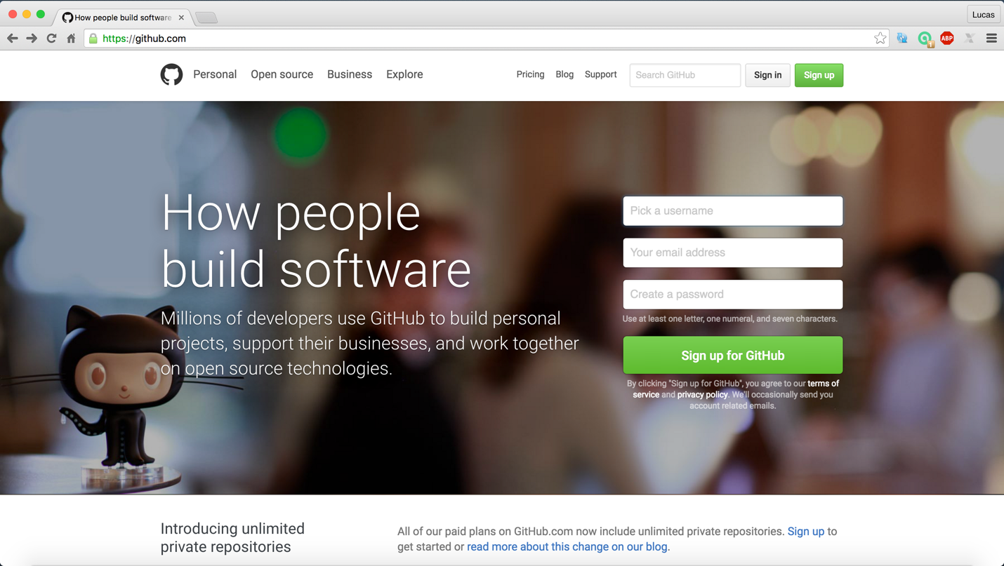



1. The results of the search should be something like this:

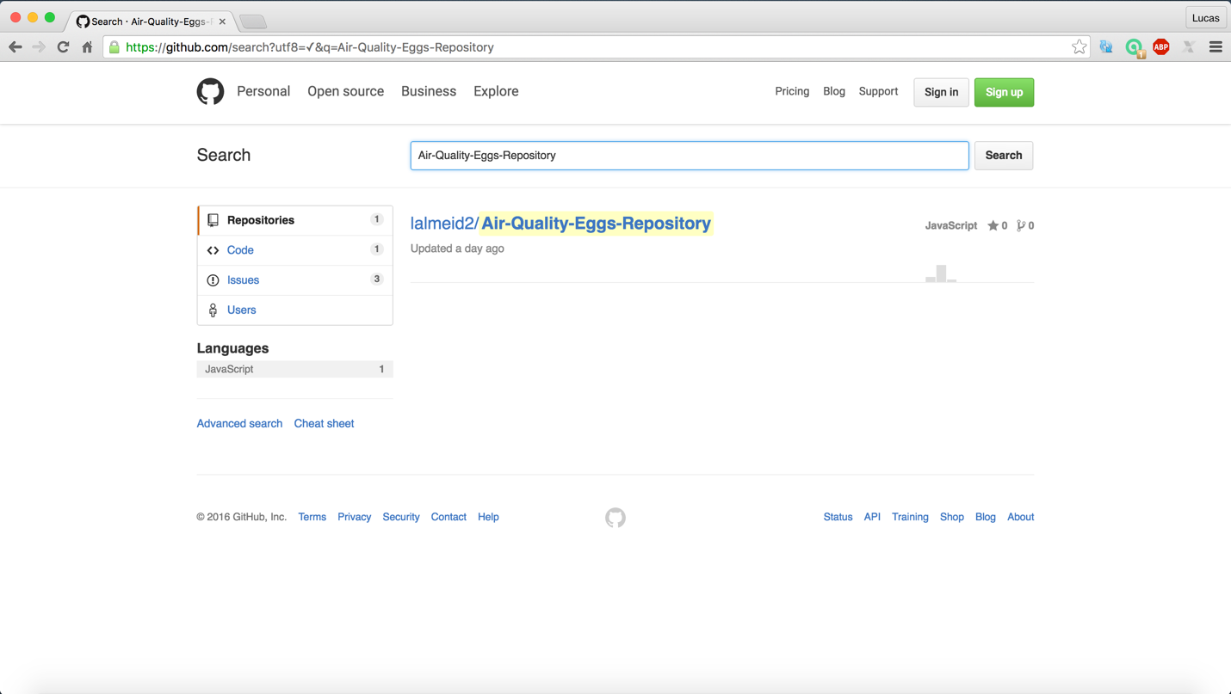

1. Click on the link showed on the previous picture;

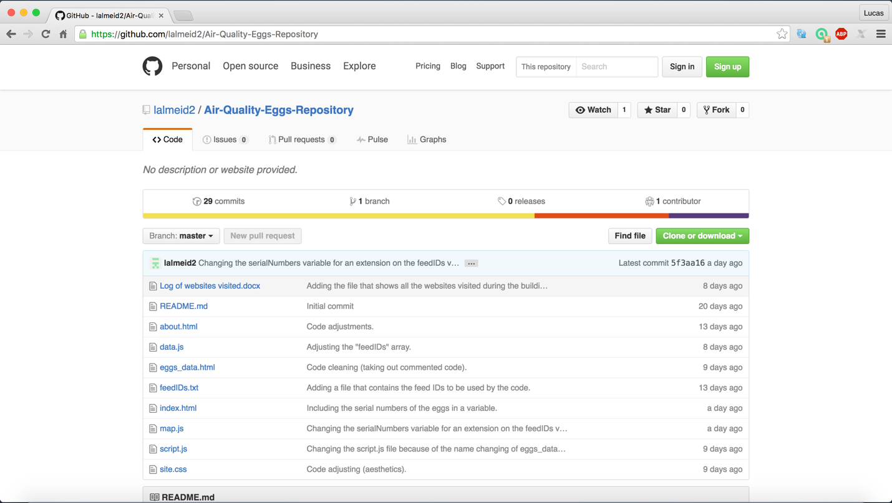

1. To copy the files, click on “Clone or download”:

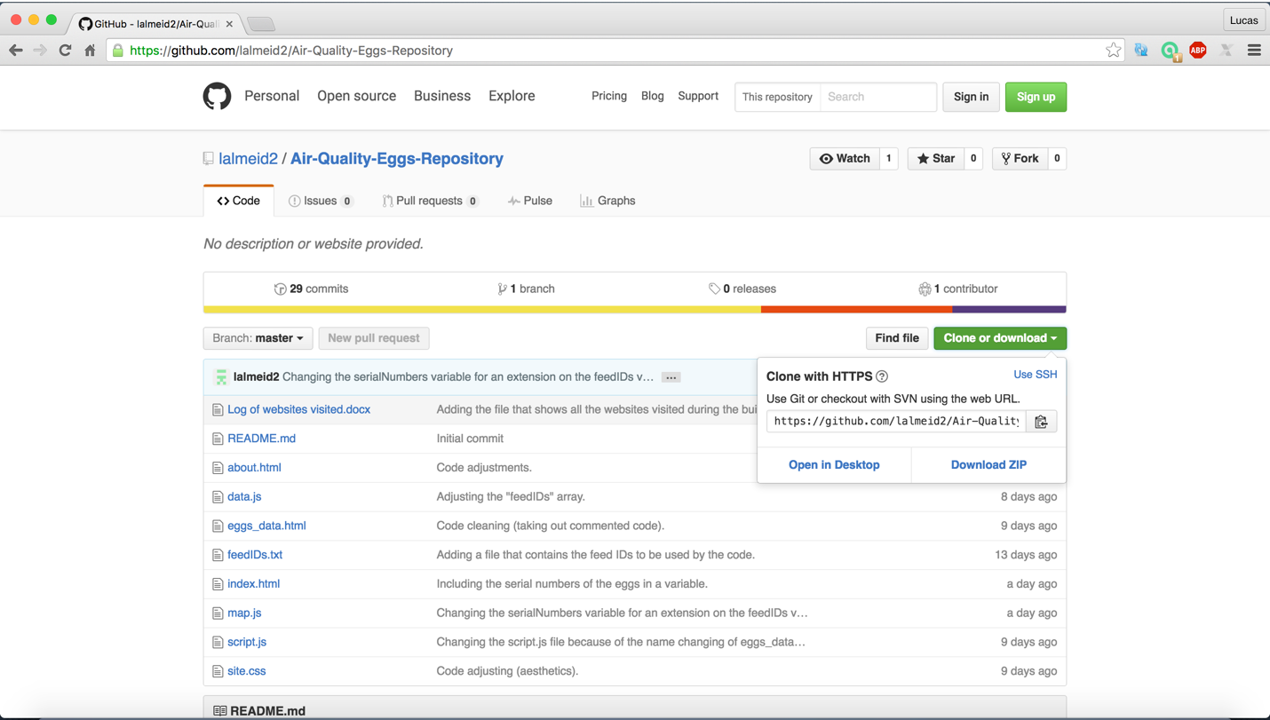

Choose one of the two options. The files should be available locally on your computer.